Segmentation and Clustering of NY City and Toronto

**A comparison of Neighborhoods**

Nikhila Anumukonda

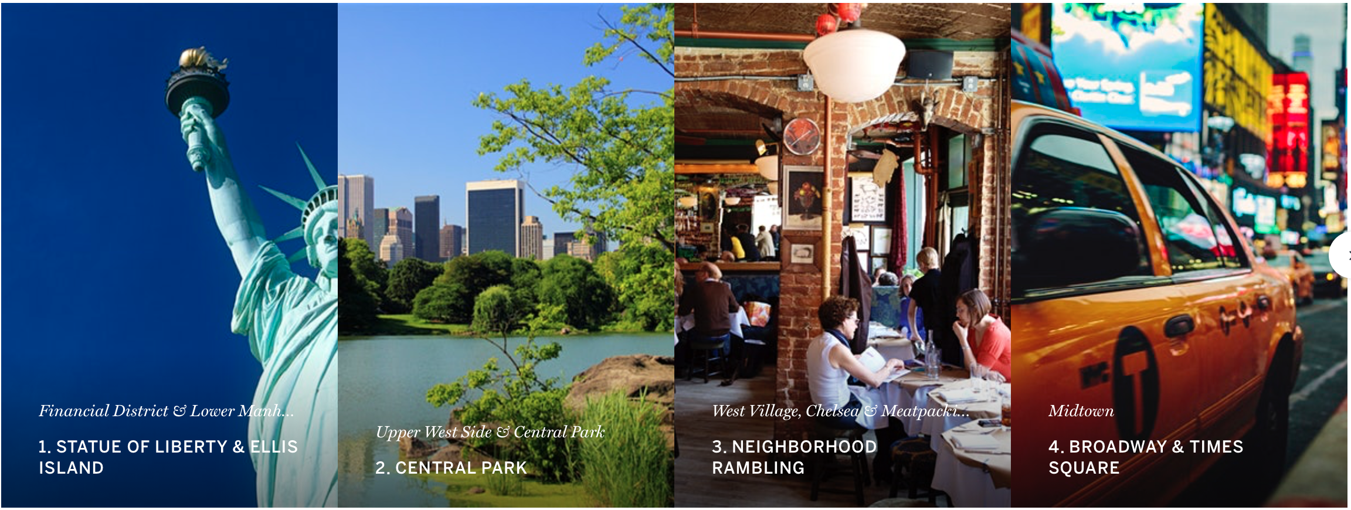

NEW YORK

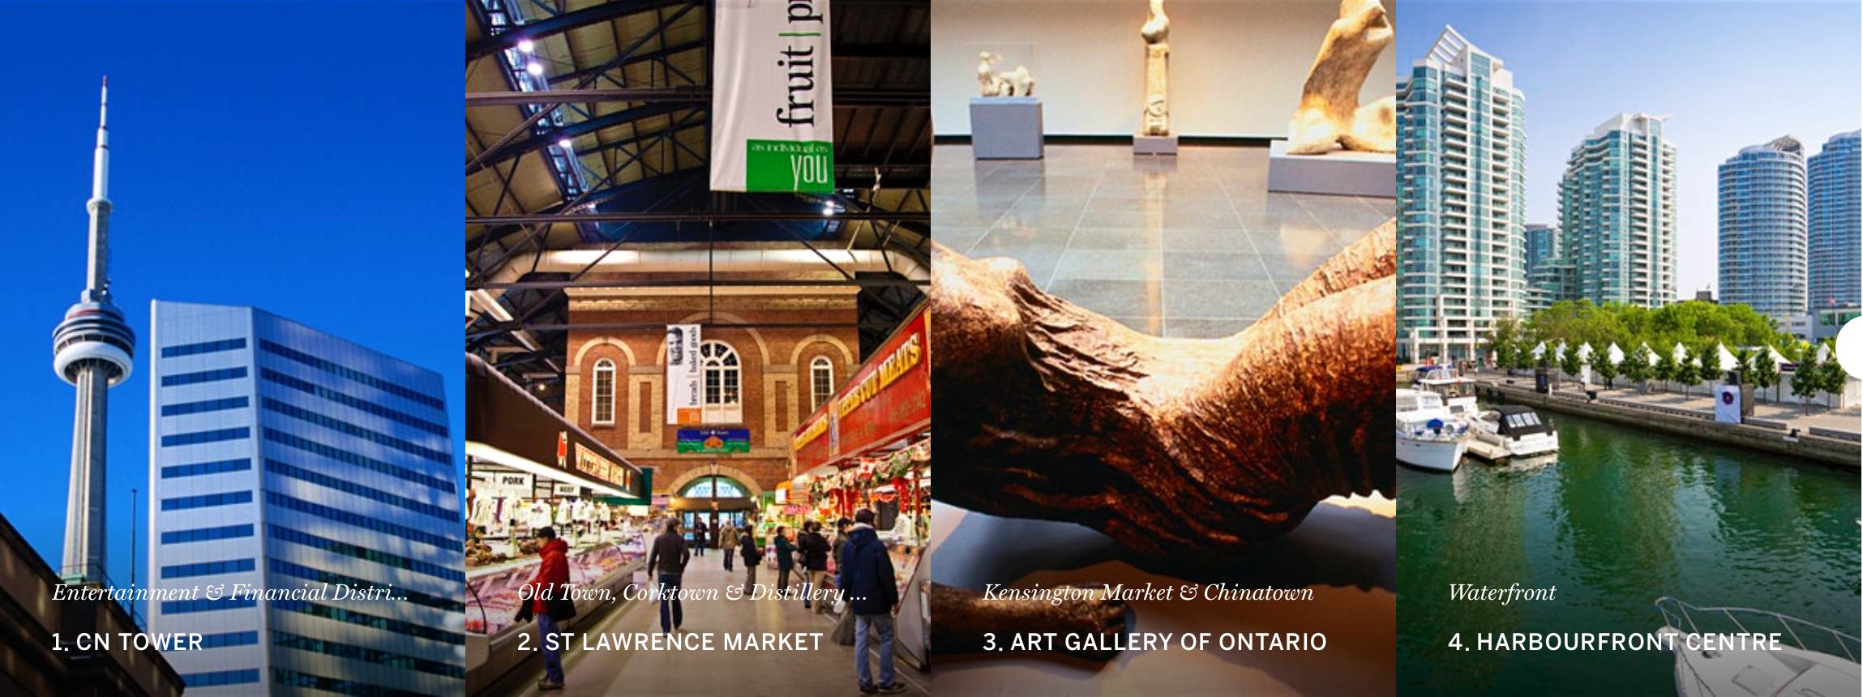

TORONTO

Table of Contents

1. Introduction/Problem statement 3

7. Data - Acquisition and Preparation 4

Neighborhood and Venue Data for Toronto 4

Neighborhood 4

Neighborhood and Venue data for New York City 14

3. Methodology and Exploratory Data Analysis 20

Most Common Venue Categories 20

Most widespread Venue Categories 22

4. Results - Clustering of Neighborhoods 24

Combining NYC and Toronto Data Neighbourhoods 26

Clustering and its Results 27

5. Discussion - Cluster Analysis 29

6. Conclusions 33

# Introduction/Problem statement

**Brief of the Two cities in question**

About Toronto

Toronto is also multi cultural and cosmopolitan city in the world. There are many languages spoken. It is considered the business and financial capital of Canada. Toronto, the capital of the province of Ontario, is a major Canadian city along Lake Ontario’s northwestern shore. It's a dynamic metropolis with a core of soaring skyscrapers, all dwarfed by the iconic, free-standing CN Tower. Toronto also has many green spaces, from the orderly oval of Queen’s Park to 400-acre High Park and its trails, sports facilities and zoo.

About New York

New York City with a population of 86.2 lakhs comprises of 5 boroughs sitting where the Hudson River meets the Atlantic Ocean. At its core is Manhattan, a densely populated borough that’s among the world’s major commercial, financial and cultural centers. Its iconic sites include skyscrapers such as the Empire State Building and sprawling Central Park. Broadway theater is staged in neon-lit Times Square. It is a diverse city with a global and cosmopolitan outlook.

**The Problem**

A young business entrepreneur from India is looking to migrate to Toronto or New York and setup a business in Toronto or New York. He needs to decide between the two options New York or Toronto. In this scenario, he wants to understand which categories of business are popular in Toronto and New York, which categories of business are rare and niche. He also wants to understand the neighboring business venues.

**Target Audience**

The audience have the following profile.

1. He is a Indian citizen with dreams to migrate to New York or Toronto because they are the business centers in their respective countries.
2. He does not know much about the New York and Toronto and their neighborhoods, hence he wants to understand feasibility of setting up business in the neighborhoods.
3. He is exploring what kind of business has less competition and which neighborhoods.
4. He has a family with skills to run the business.
5. He likes to live in a neighborhood with ample open spaces.

# Data - Acquisition and Preparation

In this section, we will discuss the process of data acquisition and preparation of the data for our analysis. There re basically two types of data we will extract and process. The neighborhood data for New York and Toronto and the Venue data for them.

The Neighborhood data is extracted from data sources provided by IBM and the Wiki page on the internet. It is then merged with the Geospatial data to get Longitudes and Latitudes of the neighborhoods.

The Venue data is retrieved from Foursquare API which is one of the largest sources of location and venue data.

## Neighborhood and Venue Data for Toronto

**Neighborhood**

For Toronto data, there is a Wikipedia page titled “List of postal codes of Canada: M” with url https://en.wikipedia.org/wiki/List_of_postal_codes_of_Canada:_M .This page lists the postal codes in Canada that start with the letter M which are the postal codes of Toronto city; it lists the postal codes with the neighborhood and borough name associated with each postal code.

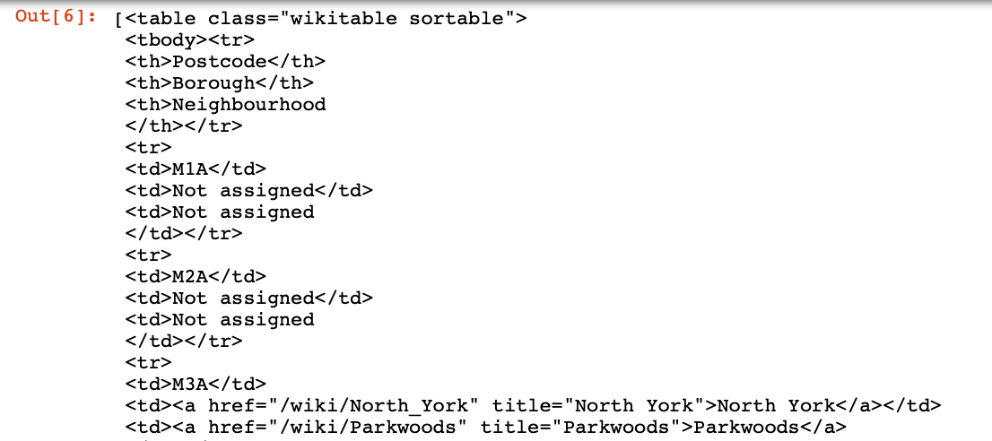

To download this webpage and extract the relevant data from it,the BeautifulSoup function was used. The resulting dataset has 103 neighbourhoods.

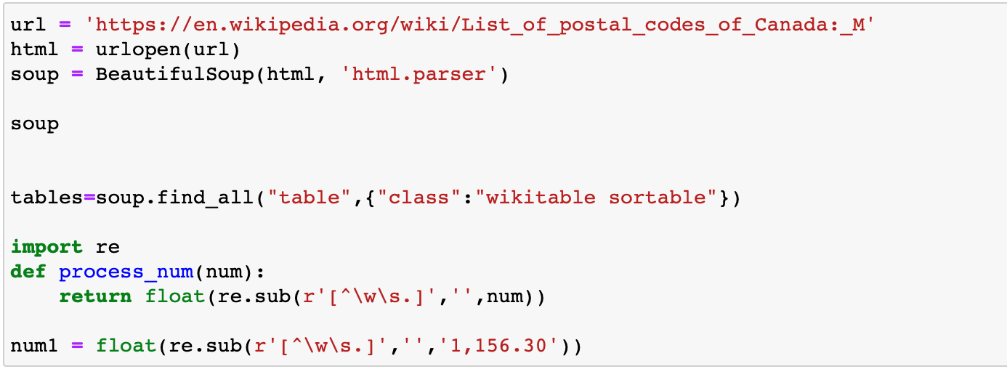Figure 1 Code to scrape data from the wiki page

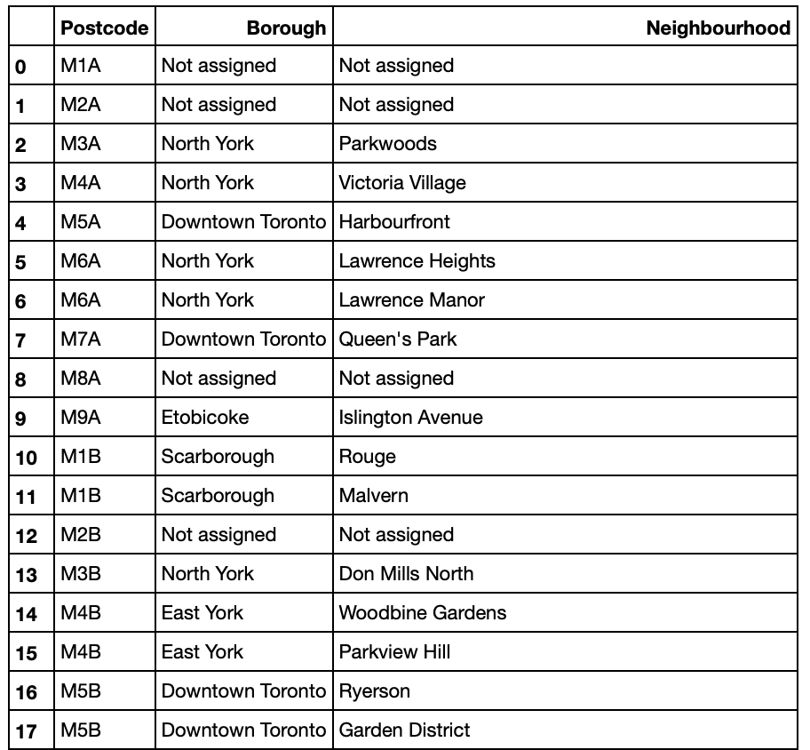

Fig 2 : List of neighborhoods for Toronto

Figure 2: Toronto’s postal codes with neighborhood and borough names

The data has Postcode, Borough and neighborhood information. The above table shows part of the resultset. The total number of neighborhoods are 103. It is observed that there some data elements that need cleaning such as :

1. Borough “Not assigned”
2. Neighborhood “Not assigned”
3. Neighborhoods with same postcodes and boroughs
4. Merge the neighborhoods which have same Borough
5. Filter and fetch data related to Toronto as the Borough

The code and result sets are as given in the following paragraph.

1. **Borough “Not assigned”**

From Fig 2, we can see that Post codes M1A and M2A do not have a Borough assigned. Such data does not add value for our analysis. So, with the following code we will remove data with Borough “Not assigned” and the resulting dataset will be as in Fig 3.

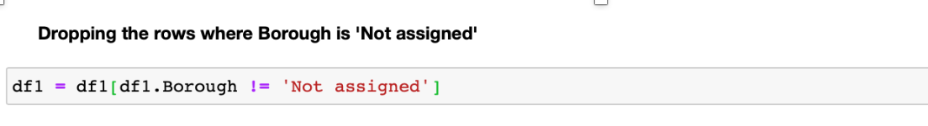

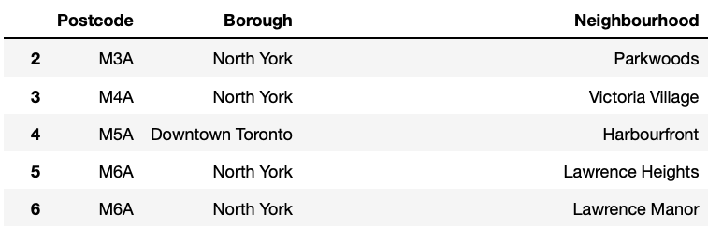

Fig 3 : Data without Borough “Not assigned”

1. **Neighborhood “Not Assigned”**

Some of the neighborhoods have value “Not assigned”. Next step is to replace the name of the neighbourhoods which are 'Not assigned' with names of Borough. In Fig 4A, M7A, Queen’s Park neighborhood is “Not assigned” on the left, with the code snippet of Fig 4B, we replace the neighborhood name with the Borough name as shown on the right.

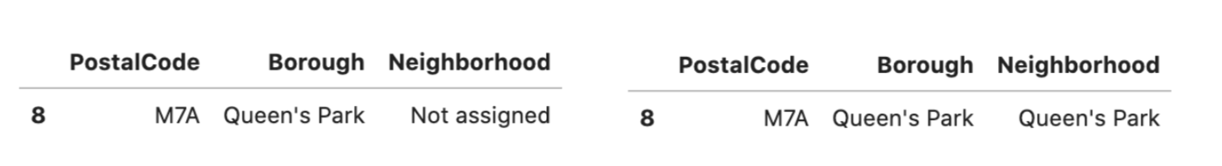

Fig 4A : result of replacing “Not assigned” neighborhood with borough name

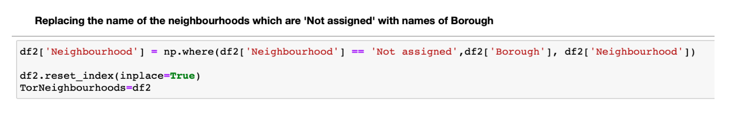

Fig 4 B: Code snippet for replacing the name of the neighbourhoods which are 'Not assigned' with names of Borough.

1. **Neighborhoods with same postcodes and boroughs**

M5B has same boroughs but different neighborhoods. We combine the neighborhoods with same postcodes. M6A has two neighborhoods “Lawrence Heights” and Lawrence Manor” as shown in Fig 5.

These two neighborhoods are combined and updated into the Neighborhood column.The resulting row will be as given in the Fig 7.

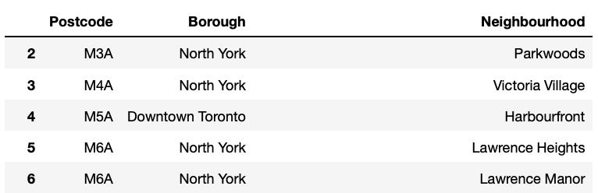

Fig 5 : neighborhoods with same postcodes

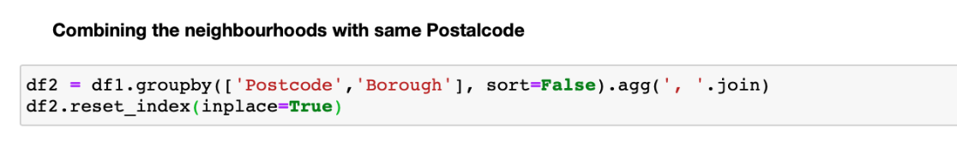

Fig 6 : Code snippet to combine neighborhoods with same postcodes

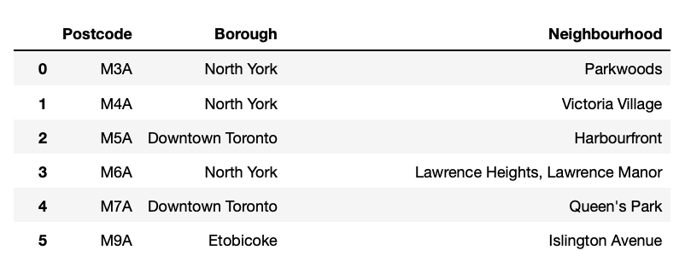

Fig 7 : Merging neighborhoods with same postcodes and boroughs

1. **Merge the neighborhoods which have same Borough.**

There are neighborhoods with same Borough like the one given in Fig 8.

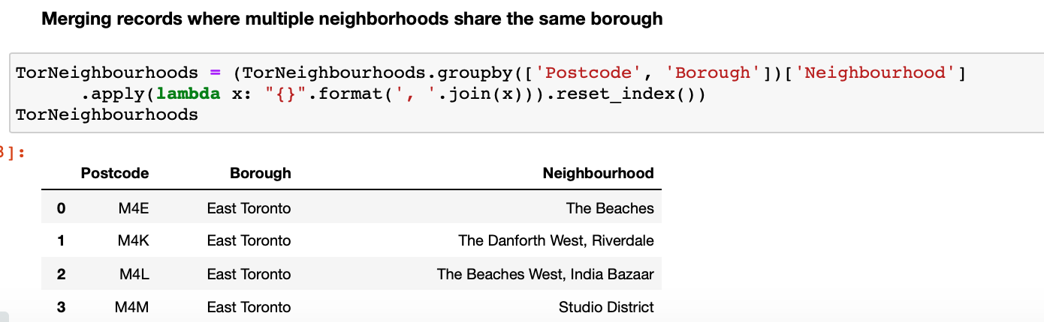

Fig 8 : Merged neighborhoods with same Borough

1. **Filter and fetch data related to Toronto as the Borough**

In the next step, we filter the dataset to represent Toronto boroughs only.The result will be as show in Fig 10.There are 4 boroughs and 39 neighborhoods.

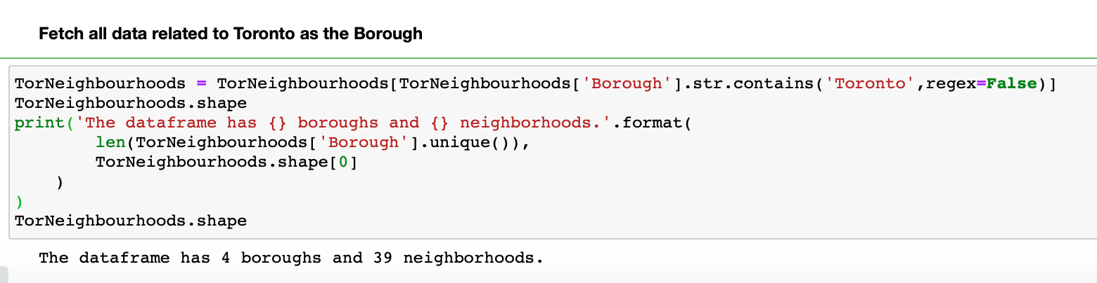

Fig 9 : Code snippet to filter Toronto Borough

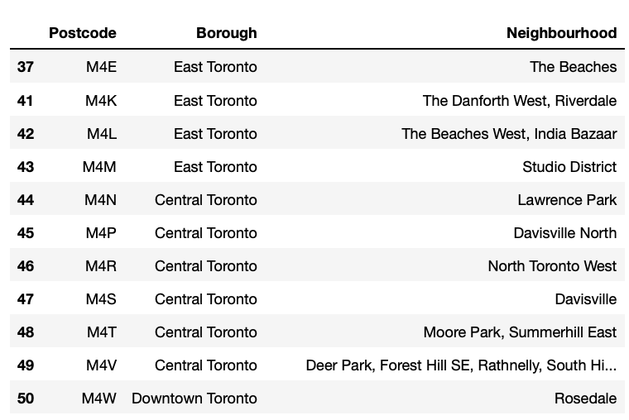

Fig 10 : Dataset with Toronto Boroughs only

Now, We require the Longitudes and Latitudes for each of the neighborhoods. We read from the CSV file provided for IBM and merge the data with the TorNeighbourhoods dataset to get both neighborhood data along with the coordinate data. Fig below shows the contents of the CSV file https://cocl.us/Geospatial_data/

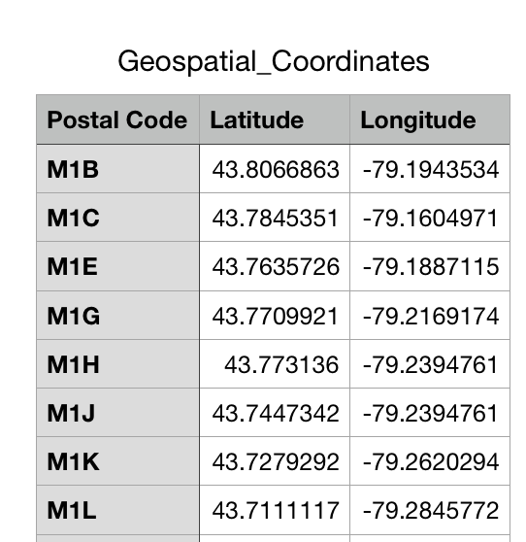

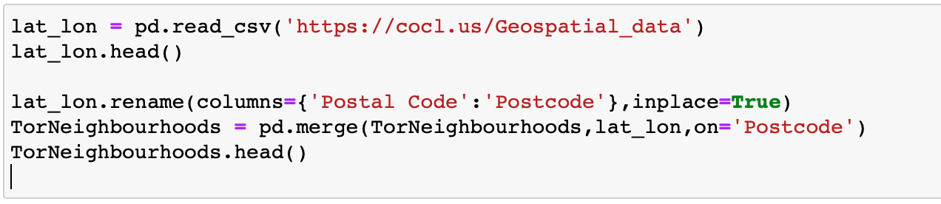

Fig 11 : Code to fetch Longitude and latitude data

The resulting dataset would have Postcode, Brough, Neighbourhood, Latitude and Longitude as shown in Fig 12.

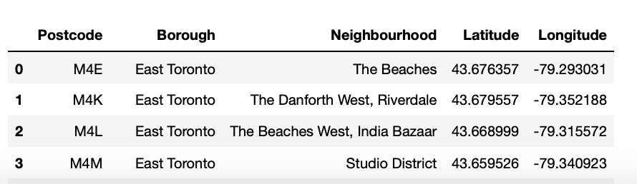

Fig 12 : Resulting dataset with Longitude and Latitude

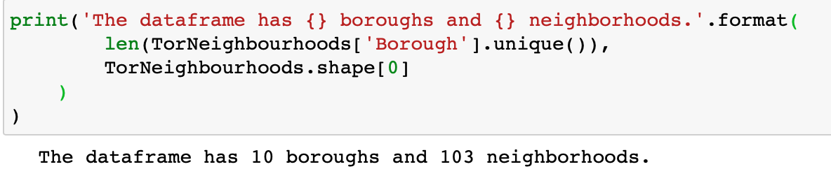

Fig 13: The dataset has 10 boroughs and 103 neighbourhoods

In the next step, we build the map of all Toronto neighbourhoods. For this , we fetch the longitude and latitude of Toronto and use Folium to draw the map.

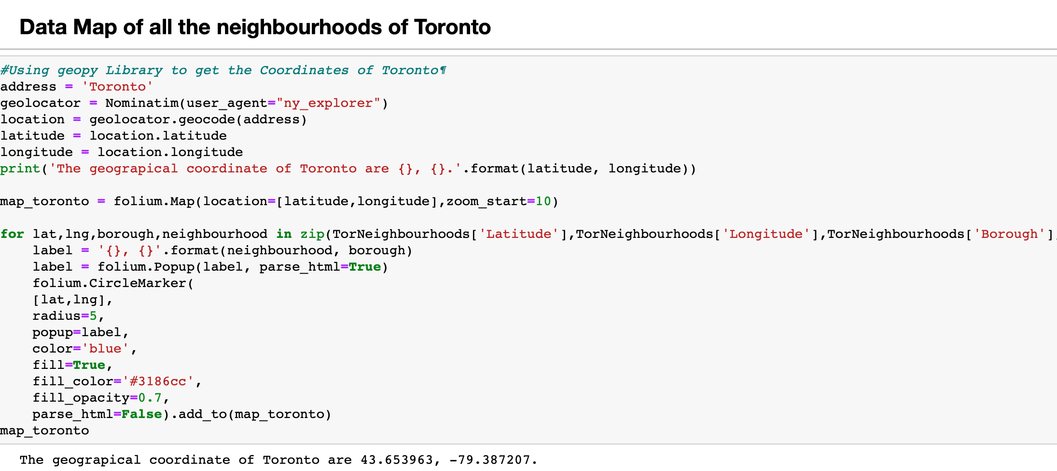

In this code snippet, we use the geopy library to pass the address of. Toronto and fetch the Latitude and Longitude. We then plot the map wih the help of folium library.

Fig 14 : code to Map neighborhoods

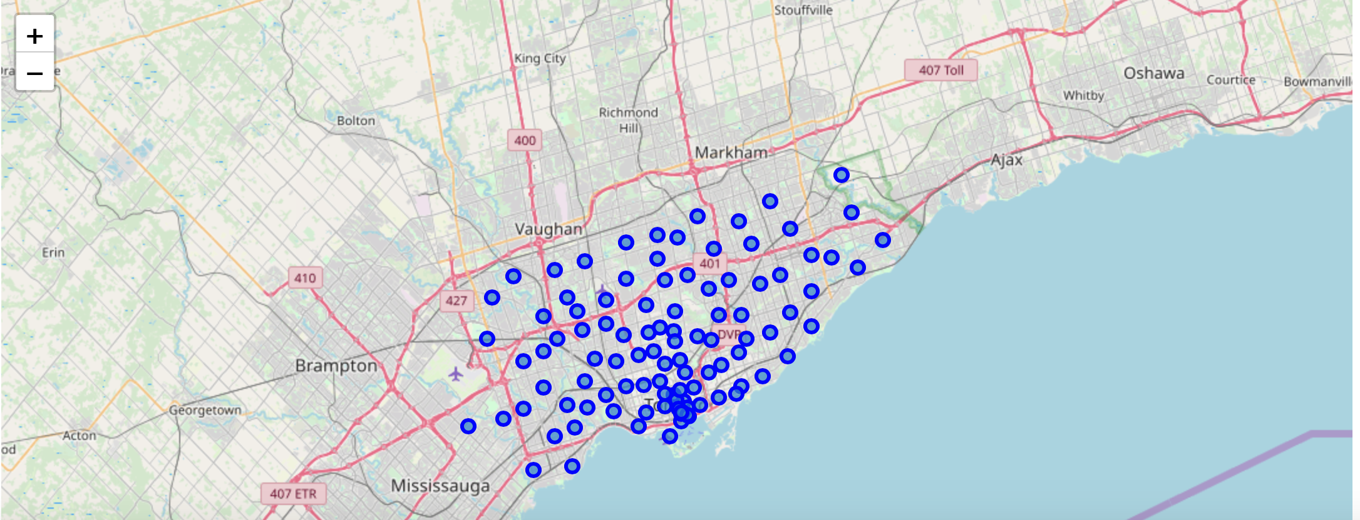

Fig16 : Resulting Map of Toronto Neighbourhoods

**Venue data**

Now, we will retrieve all the Venue data for Toronto neighbourhoods. We exclude the venues such as Building,Office,Bustop etc. Using the function getNearbyVenues, we will fetch the Venue categories for each neighbourhood.Here, we use the Foursquare API to fetch the venues Foursquare which is a popular source of location and venue data. Foursquare API service will be utilized to access and download venues data.

To retrieve data from Foursquare using their API, a URL should be prepared and used to re- quest data related a specific location. An example URL is the following:

https://api.foursquare.com/v2/venues/search?

&client_id=1234&client_secret=1234&v=20180605&

ll=40.89470517661,-73.84720052054902&radius=500&limit=100

where search indicates the API endpoint used, client_id and client_secret are credentials used to access the API service and are obtained when registering a Foursquare developer account, v indicates the API version to use, ll indicates the latitude and longitude of the desired location, radius is the maximum distance in meters between the specified location and the retrieved venues, and limit is used to limit the number of returned results if necessary.

Figure 17 shows the code used to create a function that takes as input the names, latitudes, and longitudes of the neighborhoods, and returns a dataframe with information about each neighbor- hood and its venues.

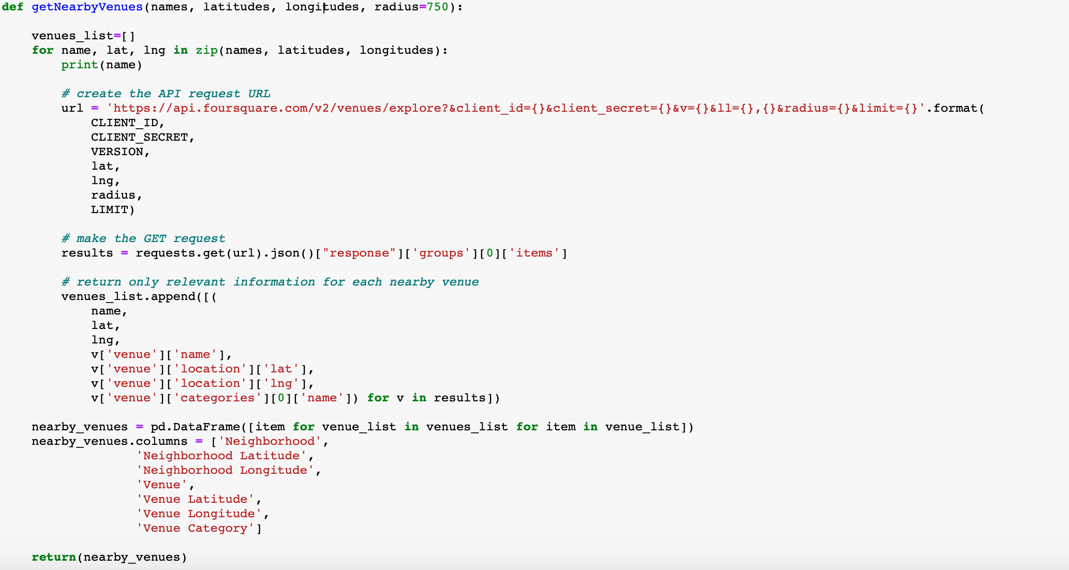

Fig 17 : getNearbyVenues function using Foursquare API.

The resulting Data frame lists the venue, Venue category, Venue latitude and longitudes as given in Fig 18.

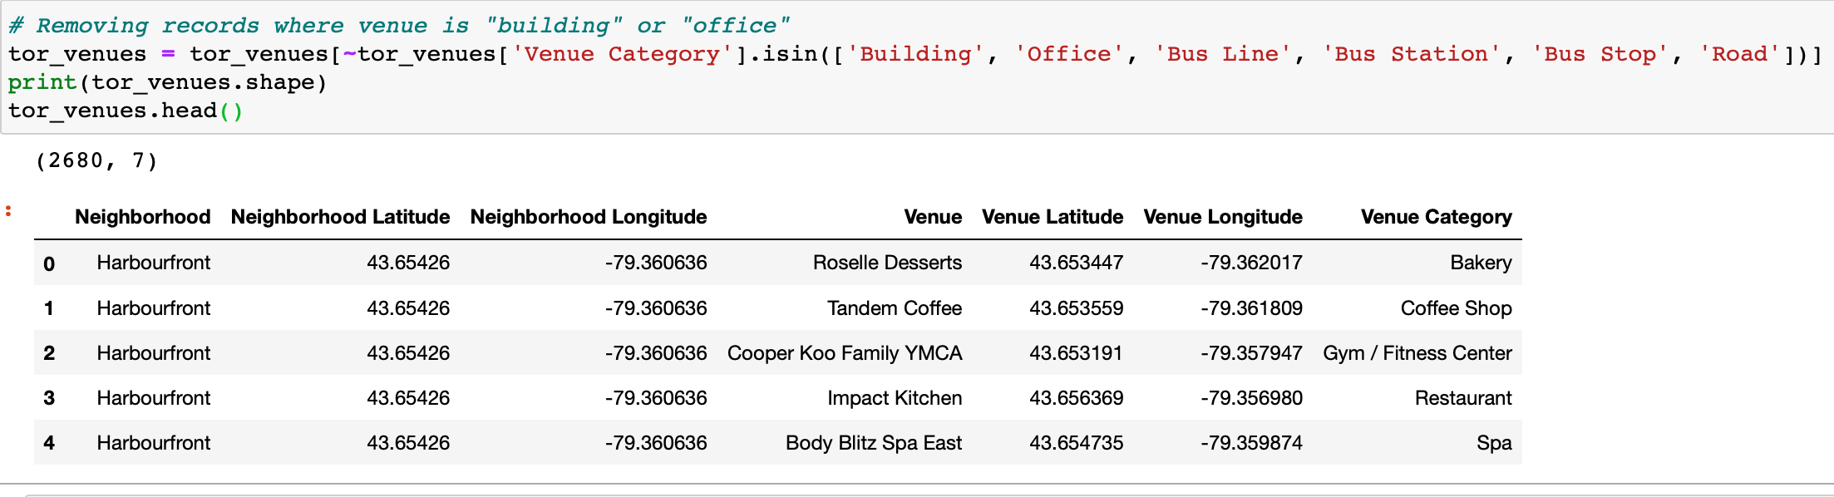

Fig 18 : Venue dataframe for Toronto

Grouping by the neighborhoods will fetch the number of venues in each neighbourhood. Each neighbourhood has different number of venues. For example : Adelaide King,Richmond has 99 neighbourhoods while Berczy park has 100 as shown in fig 22.

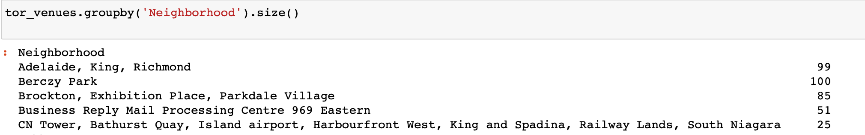

Fig 22 : Number of Venues in each neighbourhood

## Neighborhood and Venue data for New York City

**NY Neighbourhoods**

The neighborhood data for New York City was is provided by IBM at the following location <https://cocl.us/new_york_dataset>. The dataset is a JSON file that specifies the name of each neighborhood, its coordinates—latitude and longitude, its borough. Figure 23 shows the code used to process the JSON file and the resulting dataset with 306 neighbourhoods in Figure 24.The data is stored in a Pandas dataframe NYNeighborhoods

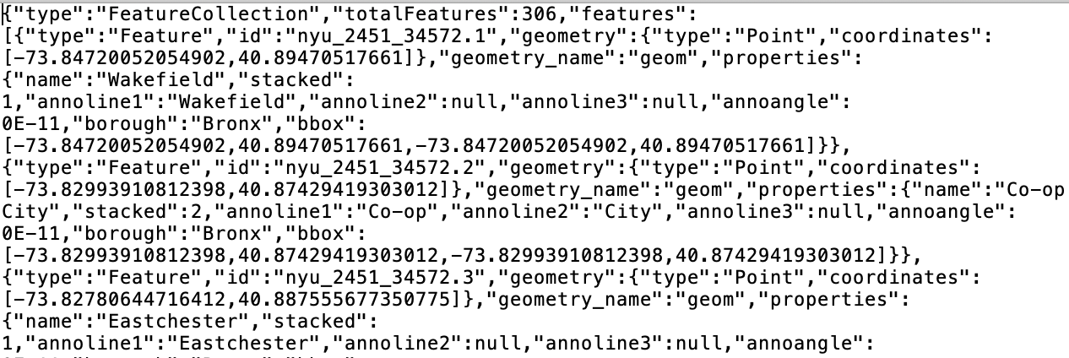

Fig 23A : snapshot of Json file

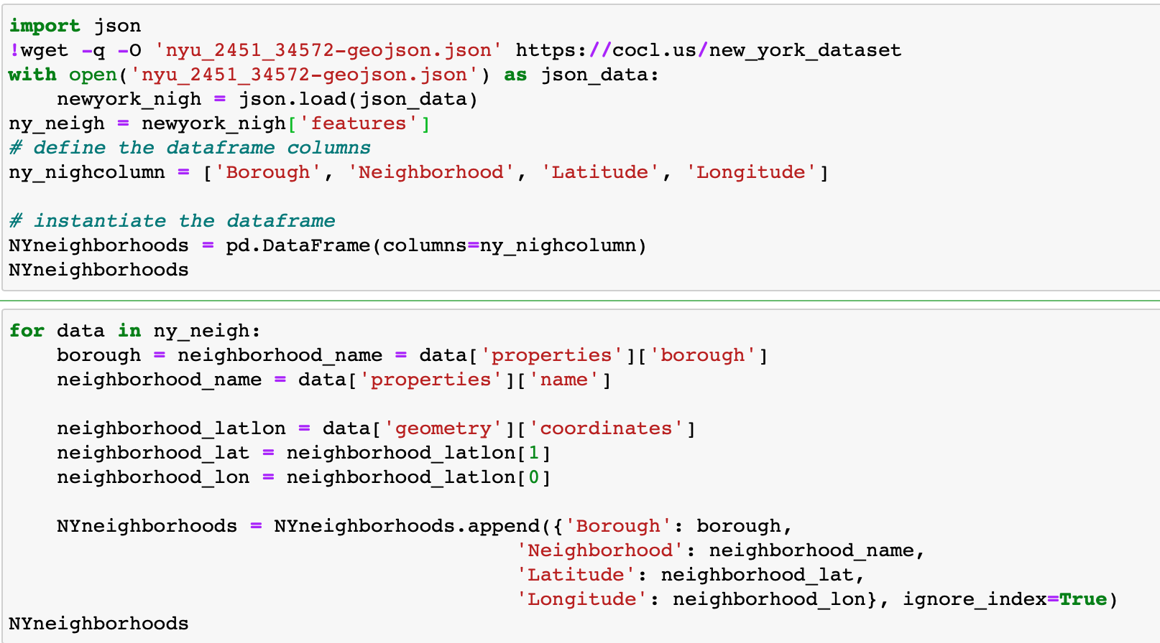

Fig 23 : importing data from Json file

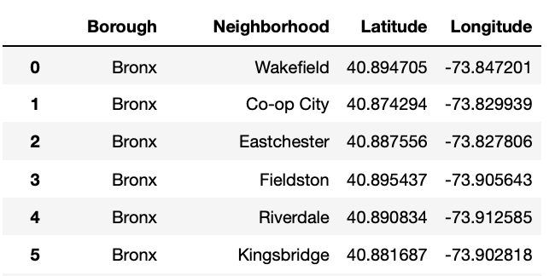

Fig 24 : Dataframe with Latitude and Longitude

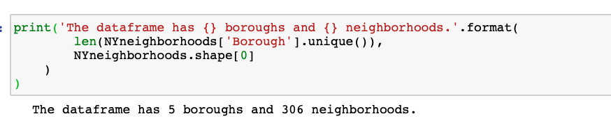

Fig 25: Number of Boroughs and Neighbourhoods

Further, there are neighborhoods that share the same name but are located in different boroughs. To deal with this case, we will include the borough name in the name of these neighborhoods.

"Bay Terrace" neighborhood which is located in "Staten Island" borough will be named "Bay Terrace, Staten Island" and the one in "Queens" will be named "Bay Terrace, Queens" as shown in Fig 26

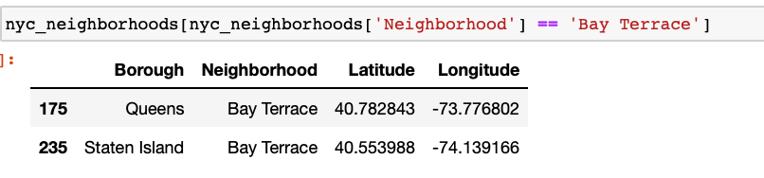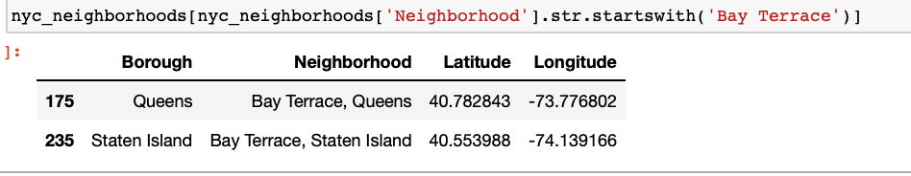

Fig 26 : Neighborhoods that share the same name but are located in different boroughs

The below code solves this issue.

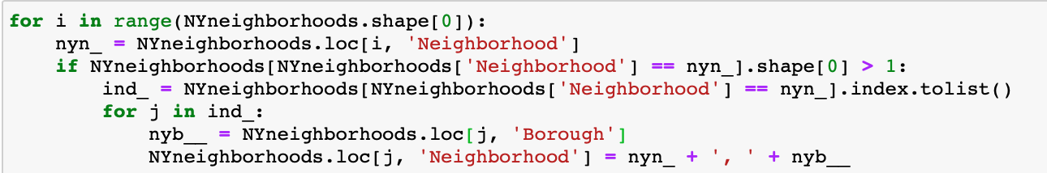

Fig 27 : Code to include borough name in the name of neighbourhoods which share same name but located in different boroughs.

With the help of Folium, we draw the map of New York for all the neighbourhoods.

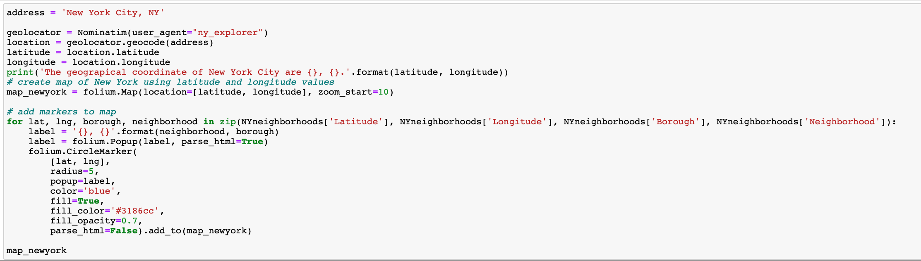

Fig 29 : Code for Data Map for New York neighbourhoods

Having data of the coordinates of NYC neighborhoods, it is possible to draw a map using Folium Python package of NYC and its neighborhoods. Figure 5 shows this map; each blue circle represents the location of one neighborhood.

Figure 30 : A map of NYC and its neighborhoods

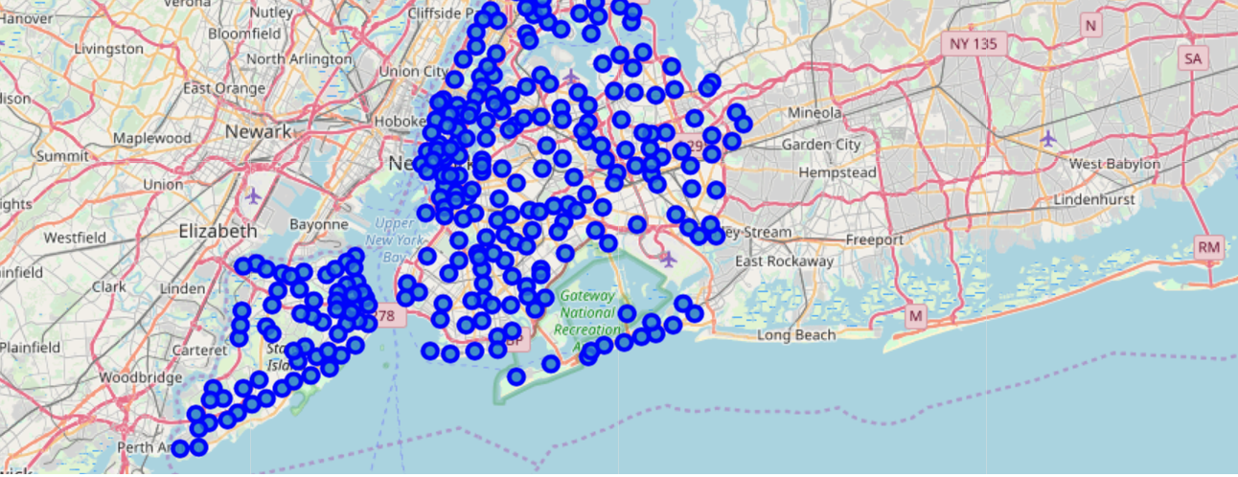

**NY Venues**

For each city, data that describes the venues of its neighborhoods and the categories of these venues is needed. Venues data will be retrieved from Foursquare which is a popular source of location and venue data. Foursquare API service will be utilized to access and download venues data.

To retrieve data from Foursquare using their API, a URL should be prepared and used to re- quest data related a specific location. An example URL is the following:

https://api.foursquare.com/v2/venues/search?

&client_id=1234&client_secret=1234&v=20180605&

ll=40.89470517661,-73.84720052054902&radius=500&limit=100

where search indicates the API endpoint used, client_id and client_secret are credentials used to access the API service and are obtained when registering a Foursquare developer account, v indicates the API version to use, ll indicates the latitude and longitude of the desired location, radius is the maximum distance in meters between the specified location and the retrieved venues, and limit is used to limit the number of returned results if necessary.

Figure 12 shows the code used to create a function that takes as input the names, latitudes, and longitudes of the neighborhoods, and returns a dataframe with information about each neighbor- hood and its venues. It creates an API URL for each neighborhood and retrieves data about the venues of that neighborhoods from Foursquare.

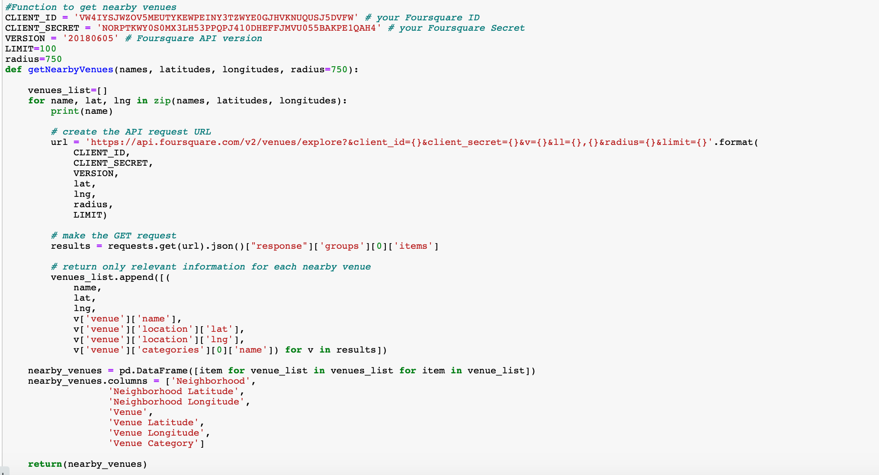

Figure 31 : Code used to build a venues dataframe for a city neighborhoods

This function “getNearbyVenues” in Fig 31 retrieves information about venues in each neighborhood.It takes as input a list of the names of the neighborhoods, a list of their latitudes, and a list of their longitudes.It returns a dataframe with information about each neighborhood and its venues.

After retrieving the venue data, venues whose category is “Building”, “Office”, “Bus Line”, “Bus Station”, “Bus Stop”, or “Road” were excluded because they are not expected to add analytical value in this project.



Fig 32

Using this function with NYC neighborhood data retrieved data about more than 2,33,375 venues in NYC neighborhoods. For each venue, venue name, category, latitude, and lon- gitude were retrieved. The head of the dataframe returned by the function for NYC is shown in Figure 33. We can see that each row in the dataframe contains data about one venue: the venue name, coordinates (latitude and longitude), and category in addition to the neighborhood in which the venue is located and the coordinates of the neighborhood.

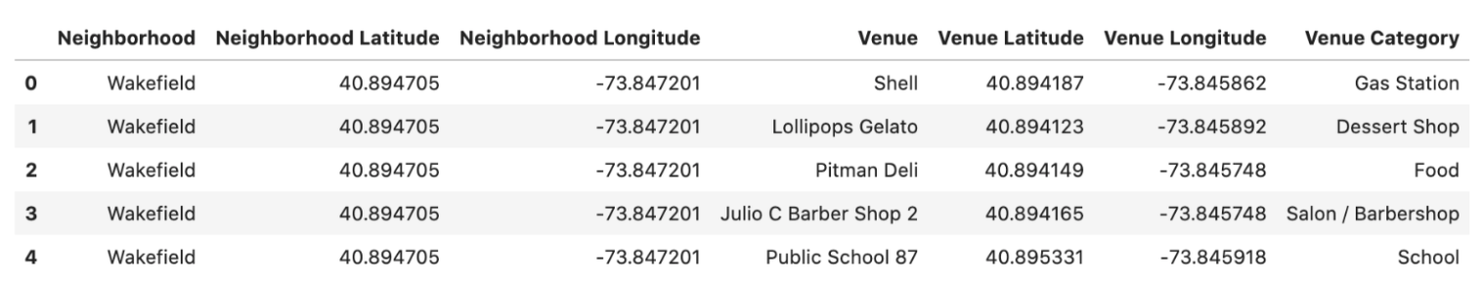

Fig 33 NY dataframe with venue details

Different numbers of venues were found in different neighborhoods: for example, data about 81 venues were returned for Allerton neighborhood, 77 venues for Annadale neighborhood, and 71 venues for Arlington neighborhood as shown in Fig 25.

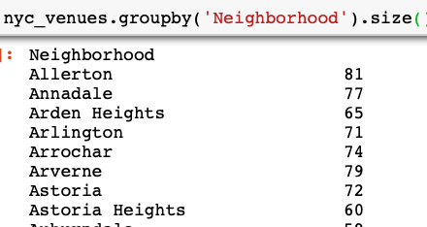

Fig 34 : Number of venues in each neighbourhood

Each venue of them belongs to one of 574 unique categories.

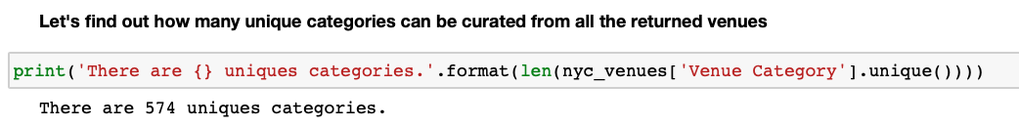

Fig 35 : Unique venue categories

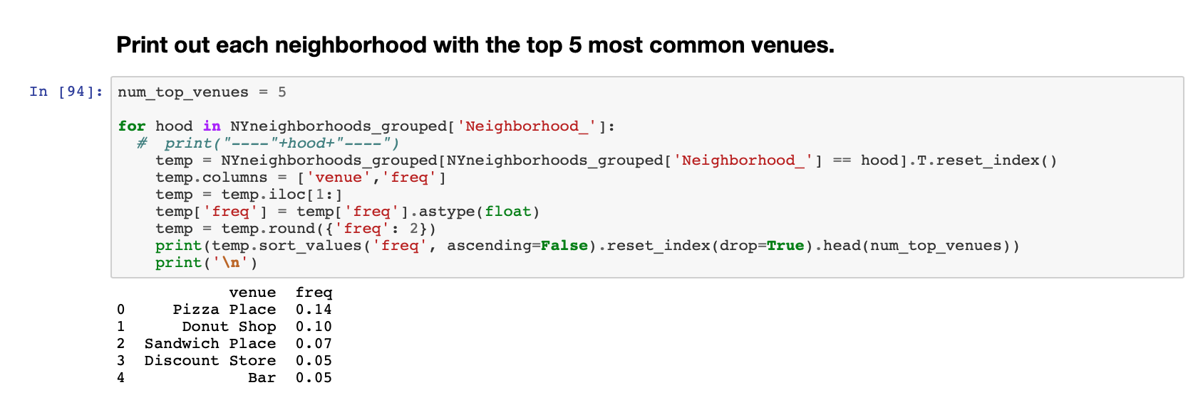

Fig 36 : Most popular top 5 venues

From this data, we can effectively understand the Venue categories in Toronto and New York neighborhoods. We analyze the neighborhoods and understand frequently occurring venues so that we get an idea about the most popular categories and most competitive markets. We will use clustering to understand different neighborhoods.

# 3. Methodology and Exploratory Data Analysis

In this section,we will explore the datasets produced in the previous section with effective visualizations to understand the data better.

## Most Common Venue Categories

What are the categories that have more venues than the others in NYC and Toronto? To answer this question, We use a bar plot can be used to visualize the popularity of the most common venue categories in each city.

**New York City**

Figure 37 shows a bar plot of the most common venues in NYC. We can see that the most common category is “Pizza Place” with 400 venues in NYC; In the second rank, the category “Coffee shop” appears with 175 venues. In the third rank comes the “Bar” category.

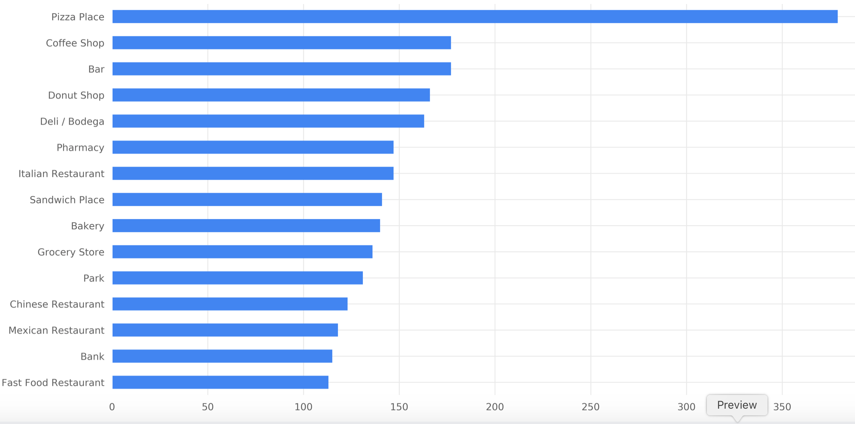

Figure 37: Most common venue categories in NYC

**Toronto**

Figure 28 shows a bar plot of the most common venues in Toronto. For Toronto, the Top 3 most common venue category is Coffee Shop, Café and restaurant .Coffee Shop with 250 venues, restaurant with 87 venues and Café with 137 venues.

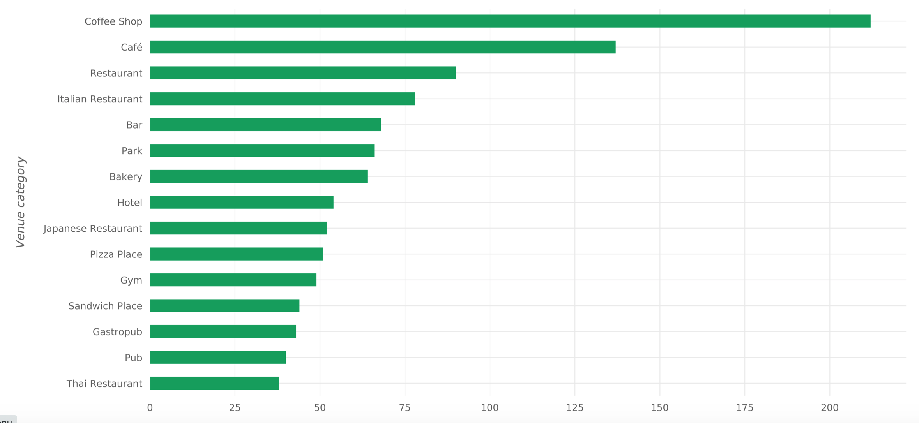

Figure 38 : Most common venue categories in Toronto

It can be seen that there are similarities between the common categories in Fig 37 and Fig 38.

## Most widespread Venue Categories

Which venue categories exist in more NYC and Toronto neighbourhoods ? For example, suppose that there are 15 venues with the category “VR Games” and that these venues exist in 7 neighborhoods only out of 80 neighborhoods; also suppose that there are 10 venues with the category “Syrian Restaurant” and that these venues exist in 10 neighborhoods—each one of them in a different neighborhood. Then it can be said that the “VR Games” category is more com- mon than “Syrian Restaurant” category because there are more venues under this category, and it can be said that the “Syrian Restaurant” category is more widespread than the “VR Games” category because venues under this category exist in more neighborhoods than the other category.

**New York City**

Figure 17 shows the most widespread venue categories in NYC. It can be seen that the order of categories this time is different than that of the most common categories (Figure 15). The most widespread category is “Salon / Barbershop” and exist in 250 neighborhoods out of the 306 neighborhoods. Next comes the “Deli / Bodega” category with venues in 250 neighborhoods also. In the third place comes the “Residential Building (Apartment / Condo)” category with venues in 230 neighborhoods.

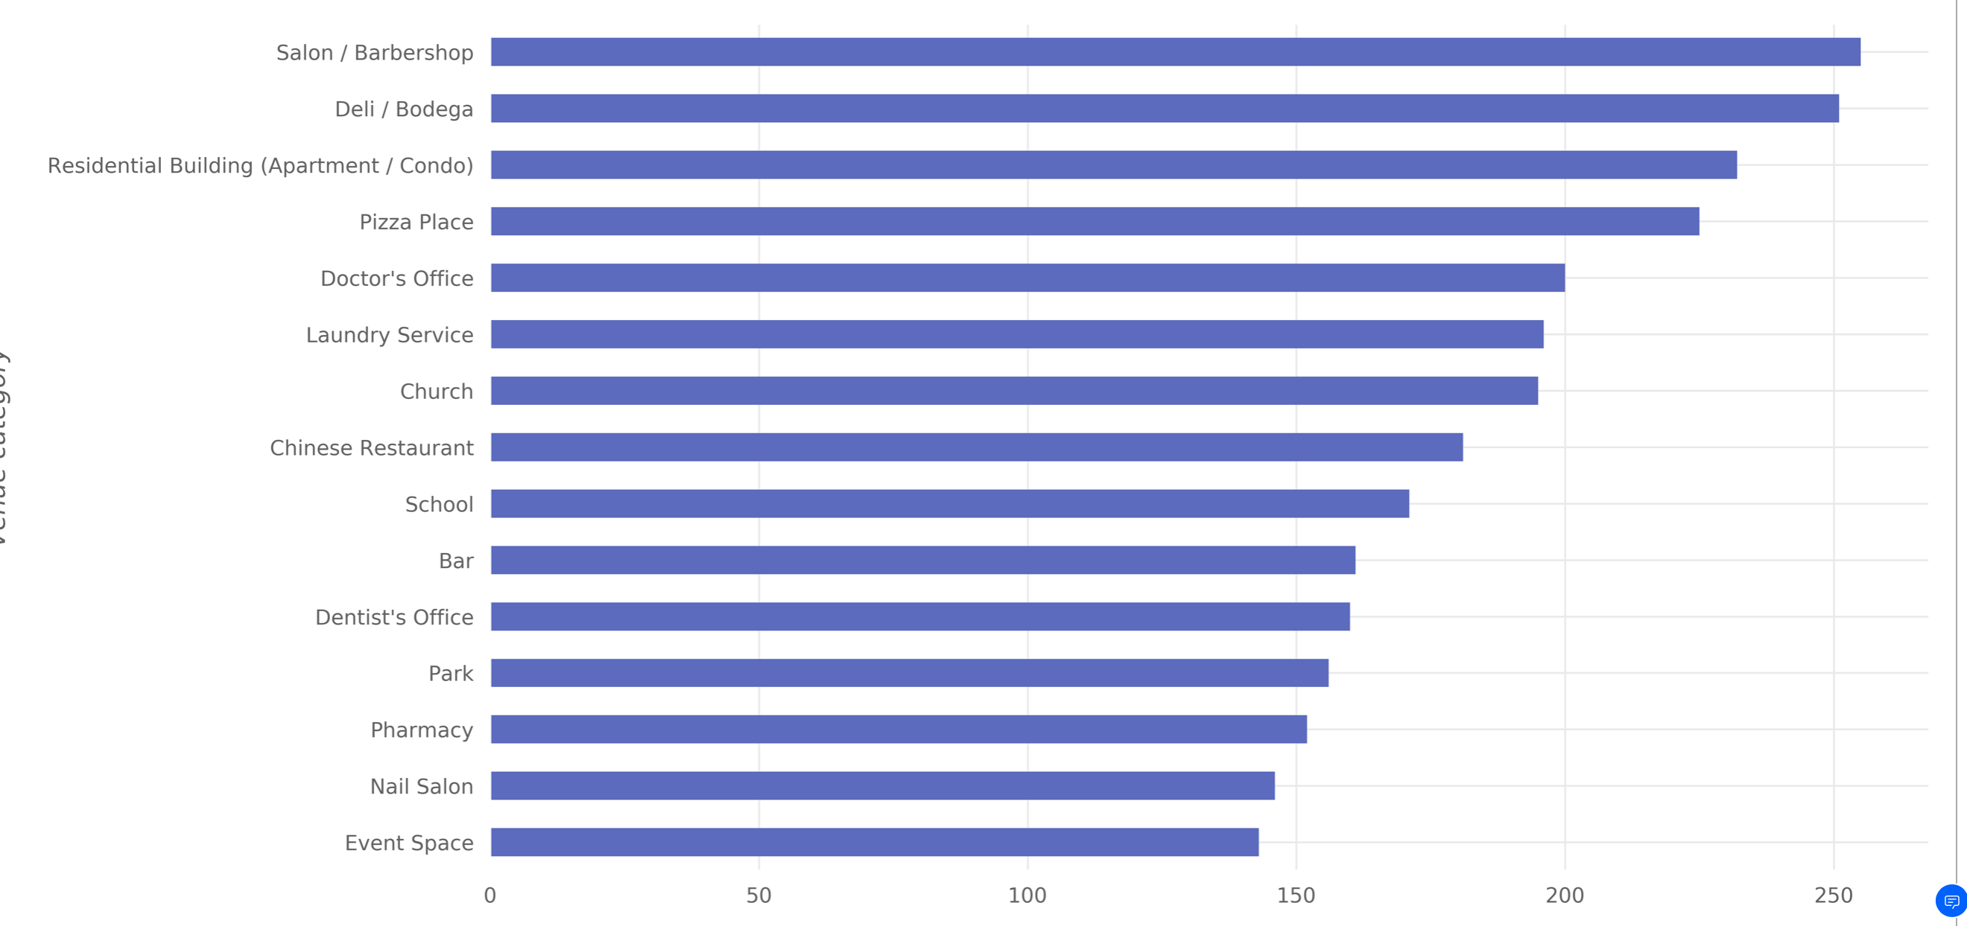

Fig 39 : Most widespread venue categories in NYC neighbouorhoods

**Toronto**

Figure 30 shows the most widespread venue categories in Toronto. In the first place comes the “Coffee Shop” category with venues in 80 neighborhoods2. Then comes “Residential Building (Apartment / Condo)” category with venues in 80 neighborhoods. And the third most-widespread category is “Park” with venues in 75 neighborhoods.

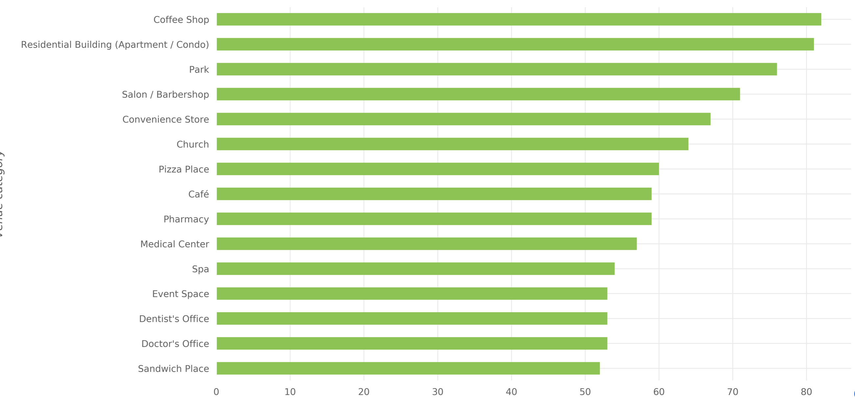

Figure 40 : Most widespread venue categories in Toronto

# 4. Results - Clustering of Neighborhoods

**Clustering** is one of the most common exploratory data analysis technique used to get an intuition about the structure of the data. It can be defined as the task of identifying subgroups in the data such that data points in the same subgroup (cluster) are very similar while data points in different clusters are very different. In other words, we try to find homogeneous subgroups within the data such that data points in each cluster are as similar as possible according to a similarity measure such as euclidean-based distance or correlation-based distance. The decision of which similarity measure to use is application-specific.

In this section, we will explore how to apply clustering to New York and Toronto neighbourhoods to find similar neighbourhoods in the two cities. We will use K-means clustering algorithm for our analysis.To be able to perform clustering, a dataset suitable for clustering is needed, so apply some

**Feature Selection**

The goal of the clustering is to cluster neighborhoods based on the similarity of venue categories in the neighborhoods. This means that the two things of interest here are the neighborhood and the venue categories in the neighborhood. Thus, the following two features “Neighborhood” and “Venue Category” will be selected out of the dataframes. Our algorithm will work with numerical features, hence we apply one-hot encoding on “Venue Category” feature and the result of the encoding will be used for clustering of the data.

After applying one-hot encoding on New York data, the resulting dataframe looks like the one shown in Figure 31.

For example, when looking at the second row in Figure 24, it can be seen that the venue category for that row is “Dessert Shop”, so the column whose value is 1 for the second row in Figure 32 is the “Dessert Shop” column; and the same applies for all rows.

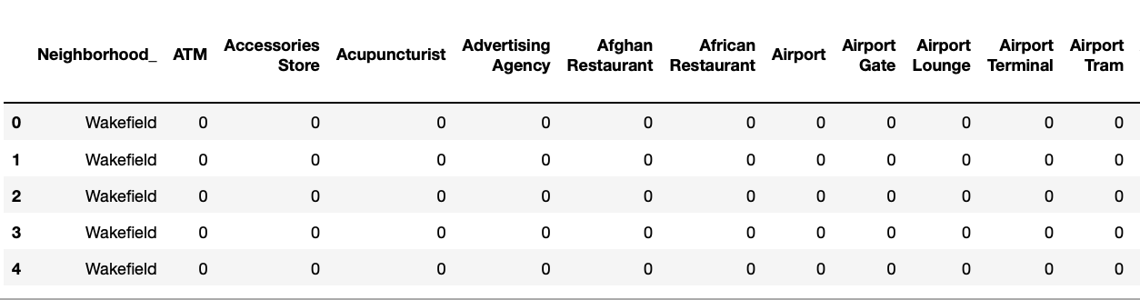

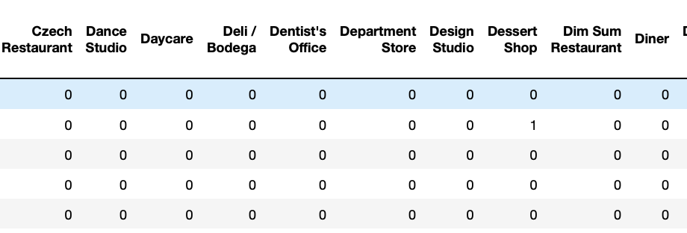

Figure 41: The result of one hot encoding on NYC data

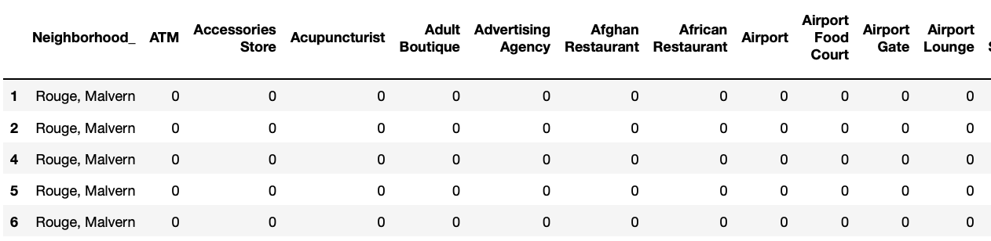

Figure 42 : The result of one hot encoding on Toronto data

The next step is aggregating the values for each neighborhood so that each neighborhood is represented by only one row. The aggregation will be done by grouping rows by neighborhood and by taking the mean of the frequency of occurrence of each category.

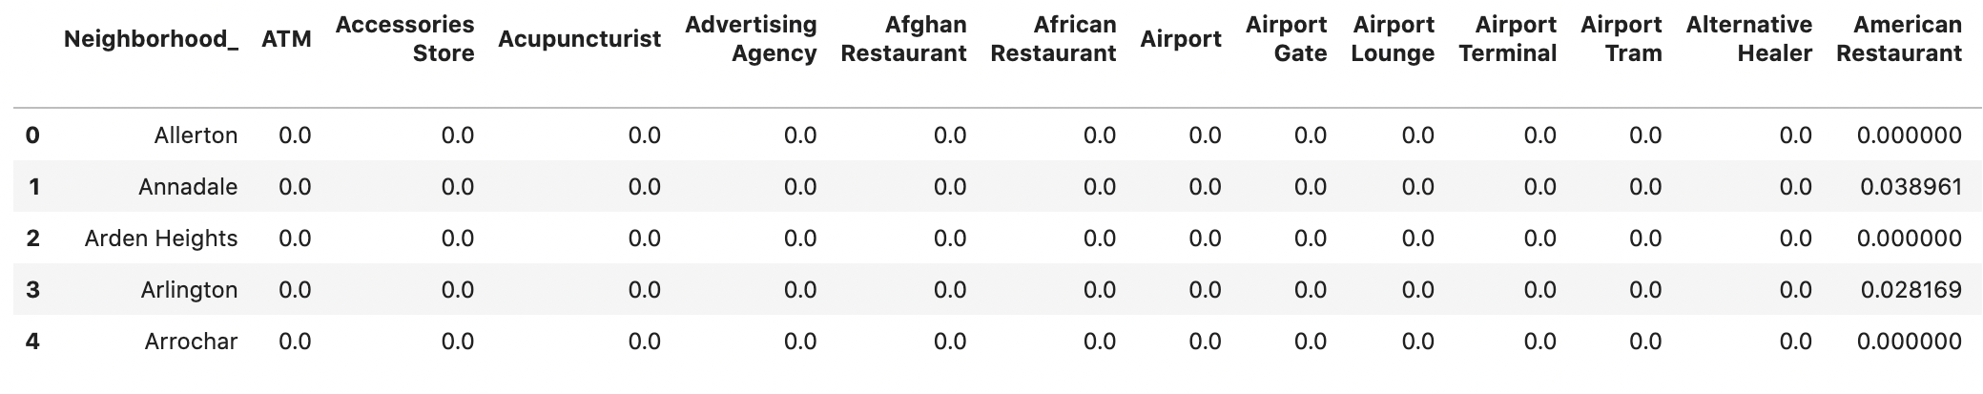

Figure 43: A part of the aggregated dataframe for NYC

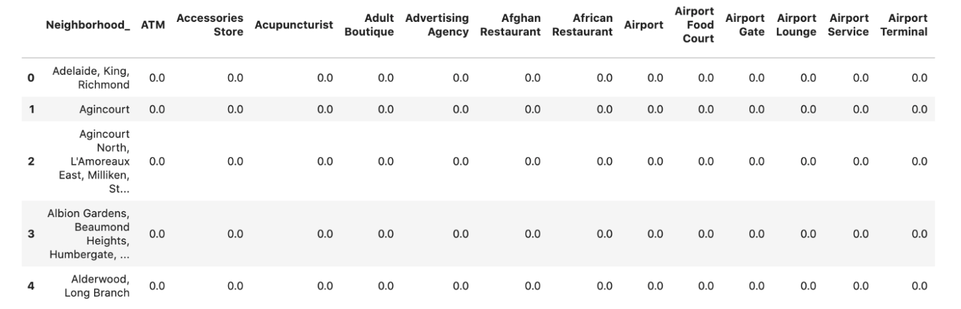

Figure 44: A part of the aggregated dataframe for Toronto

Fig 45 and 46 shows the top 5 common venues in the NY and Toronto neighbourhoods.

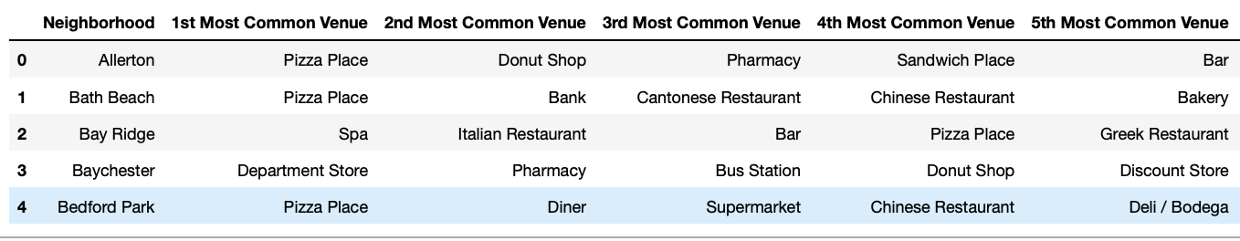

Fig 45 : Common venues in NY neighbourhoods

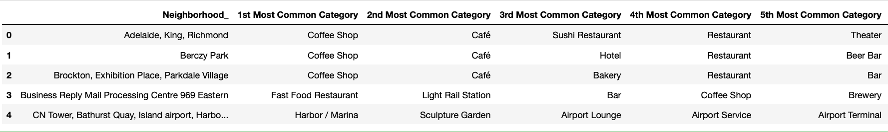

Fig 46 : Common venues in Totonto neighbourhoods

## Combining NYC and Toronto Data Neighbourhoods

The aggregated dataframes for New York and Toronto are combined before clustering. To be able to distinguish between NY and Toronto neighbourhoods, we append “_NY” and _TOR to the neighbourhood names before further processing.We combine all the venues from NY and Toronto into a dataframe.

Figure 37 shows a part of the dataframe that resulted from the combination of NY and Toronto aggregated dataframes. This dataframes contains data on 408 neighborhoods in both NY and Toronto.

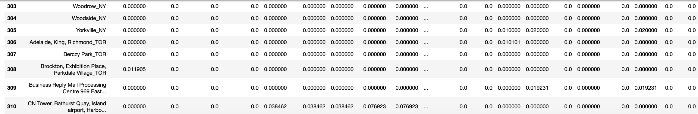

Figure 47: The combination of NYC and Toronto aggregated dataframes

**The Most Common Categories for Each Neighborhood**

Using the dataframe of Figure 47, another dataframe is created to specify the 7 most common categories for each neighborhood in NYC and Toronto. This dataframe is created by retrieving the 5 categories with the largest values for each neighborhood in Figure 47. Figure 48 shows this dataframe.

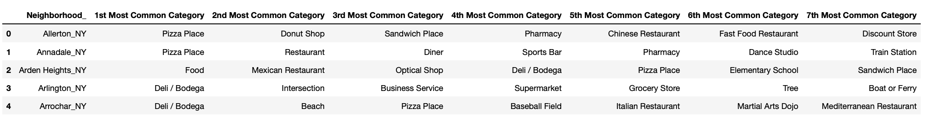

Figure 48: Most common categories for each neighborhoods

## Clustering and its Results

Clustering for Toronto Neighborhood

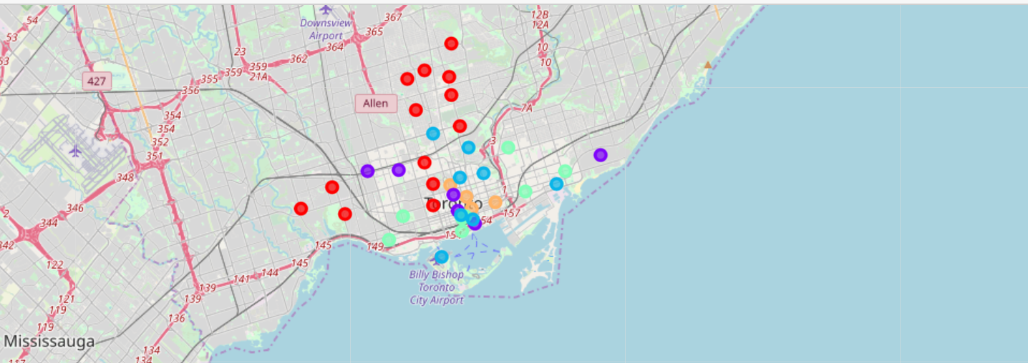

Fig 49 : Clustering Map of Toronto

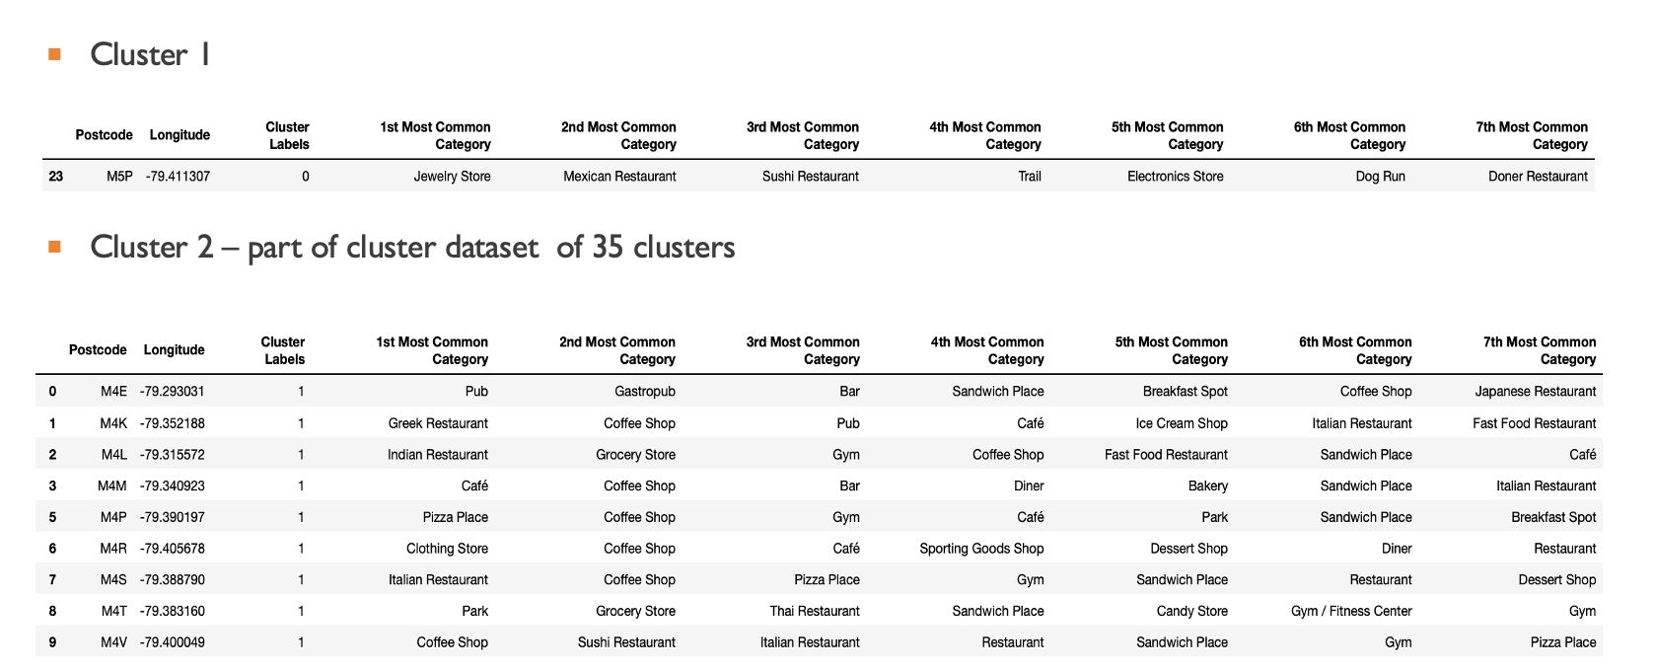

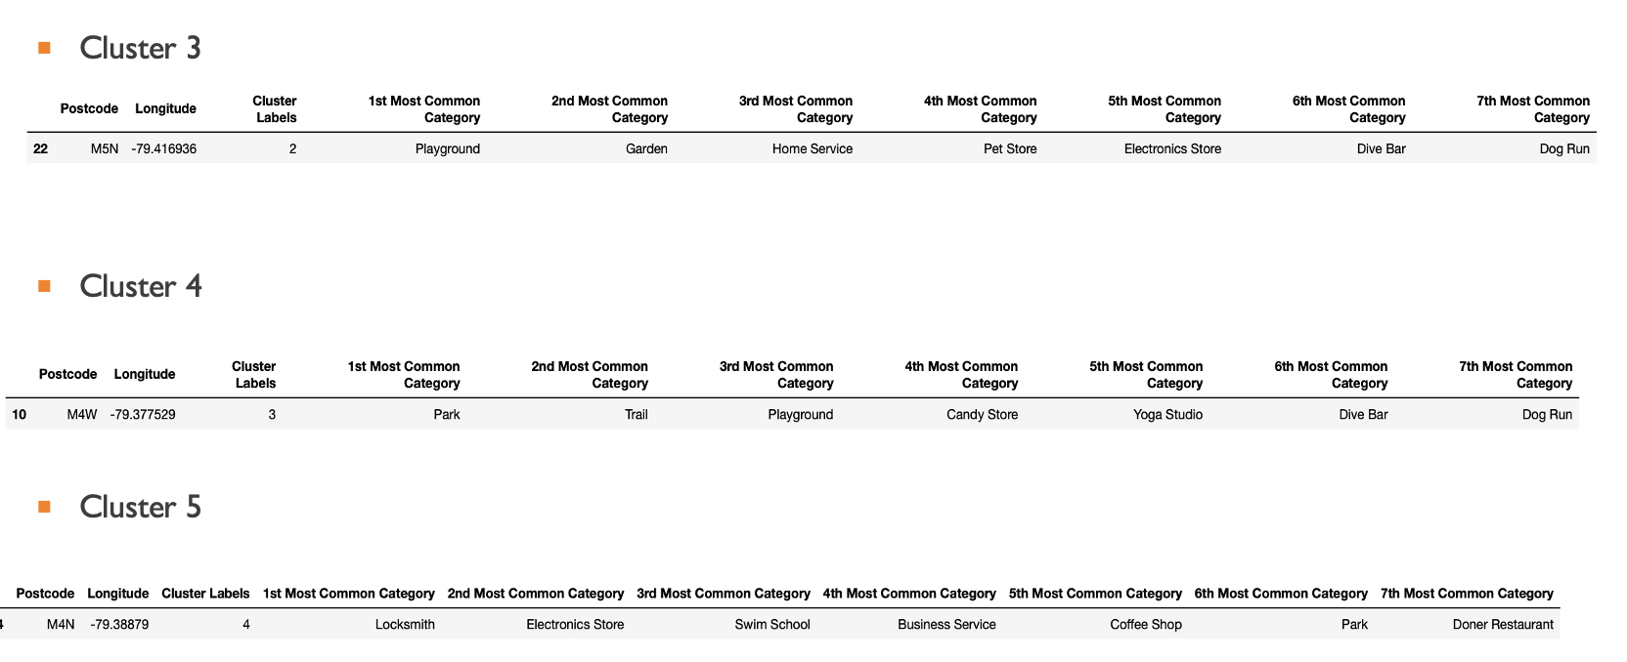

Fig 49b : Individual clusters of Toronto

Clustering for New York Neighborhood

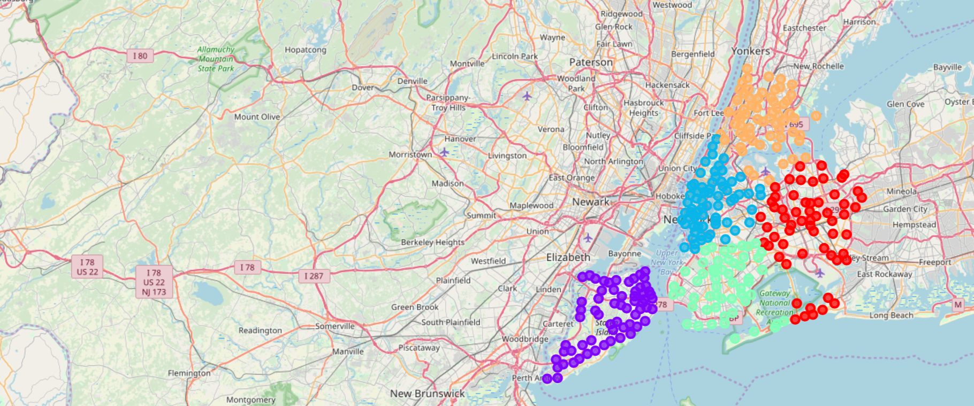

Fig 50: Clustering Map of New York

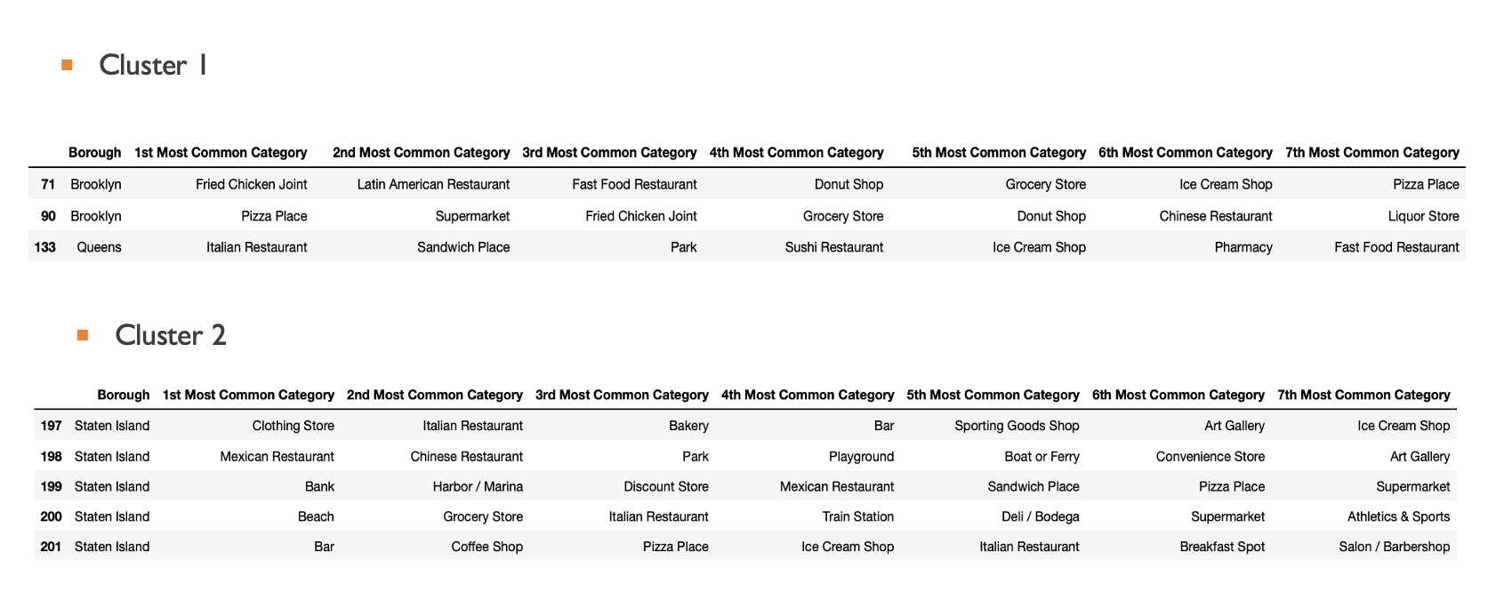

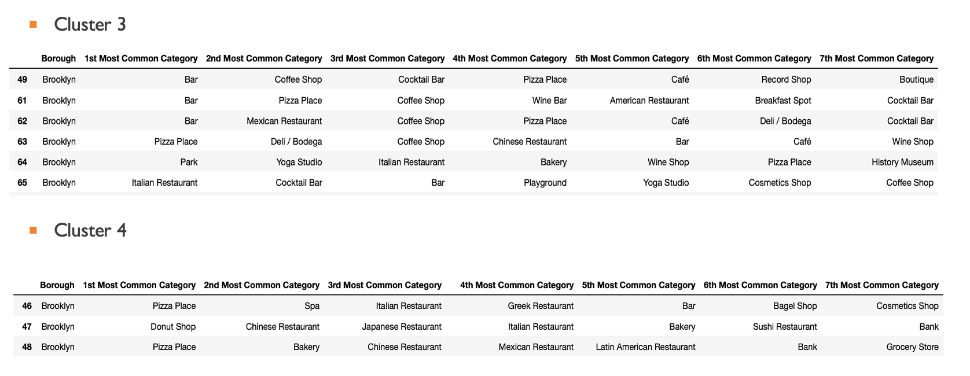

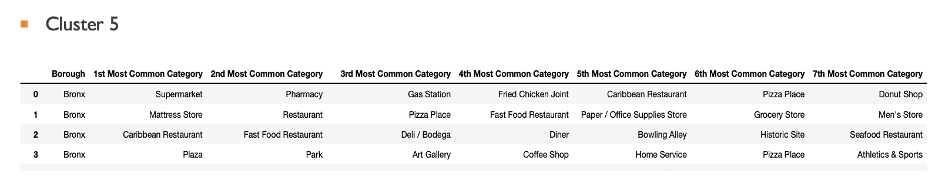

Fig 50 B : Individual clusters of New York

Clustering for combined Toronto and New York neighborhoods.

After the pre processing, with the dataframe of Figure 48, it is possible to apply the clustering algorithm.

Figure 51 shows the code used to perform clustering using the K-means algorithm of Scikit-learn library.

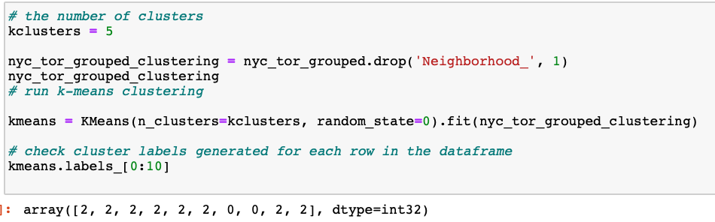

Fig 51 : Code for Clustering algorithm

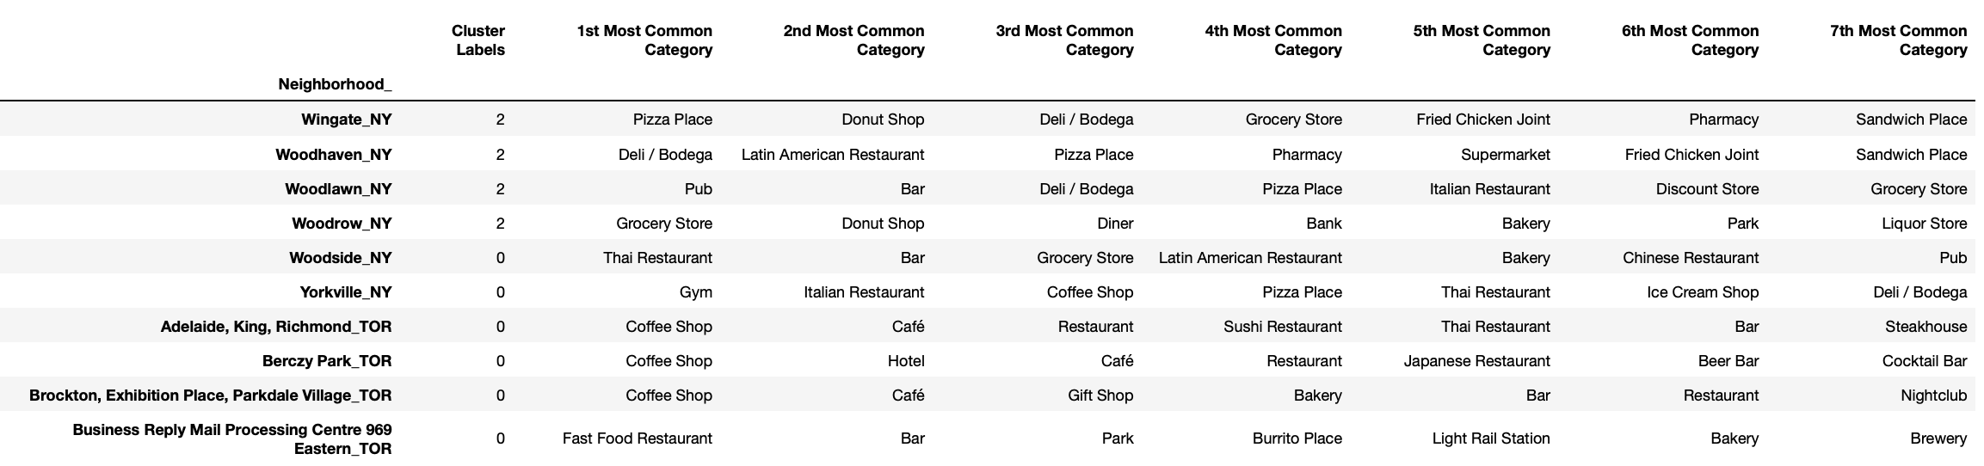

Fig 52 : Most common venue categories in each neighborhood

As can be seen in Figure 52, the clustering algorithm produced cluster-labels; these labels de- note the cluster of each record (i.e. each neighborhood) in the data. Using these labels and the dataframe of Figure 48, a dataframe is constructed to show the neighborhoods of NYC and Toronto, the cluster to which each neighborhood belongs, and the most common venue categories in each neighborhood. This dataframe can be seen in Figure 50.

The output of the clustering operation is 5 clusters with cluster labels 0, 1, 2, 3, and 4. Each cluster is expected to contain a group of similar neighborhoods based on the categories of the venues in each neighborhood. The clustering algorithm was run on 406 neighborhoods in NYC and Toronto.

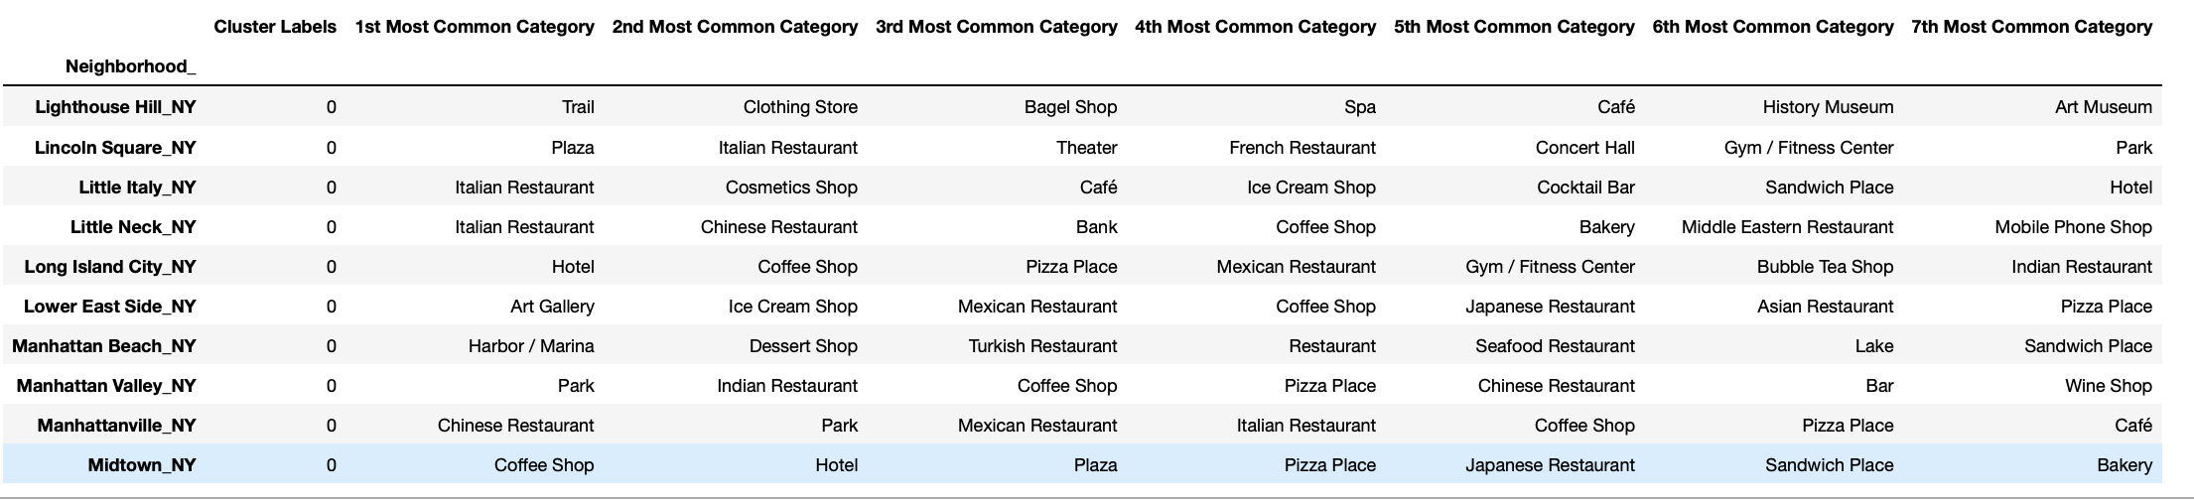

Figure 52: Some records that belong to the first cluster



Figure 53: Some records that belong to the second cluster

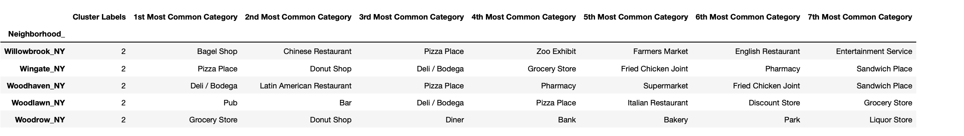

Figure 54: Some records that belong to the third cluster

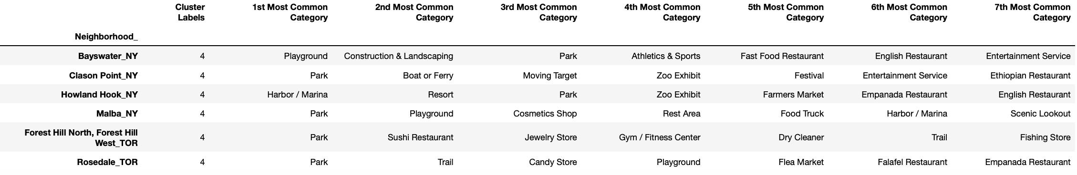

Figure 55: Some records that belong to the fourth cluster

# 5. Discussion - Cluster Analysis

The clustering algorithm grouped neighborhoods of NYC and Toronto in 5 clusters based on the similarity between their venues. Now, these clusters will be investigated to see the most common categories in each of them. Figures 48 show the most common 7 venue categories in each cluster; for each common category, the percentage of venues of that category in the neighborhoods of the cluster is shown also.

In Fig 55 below, we can see the most common venue categories in each cluster along with the percentage of occurrence in that cluster.

Figure 55: Most common venue-categories in each of the 5 clusters

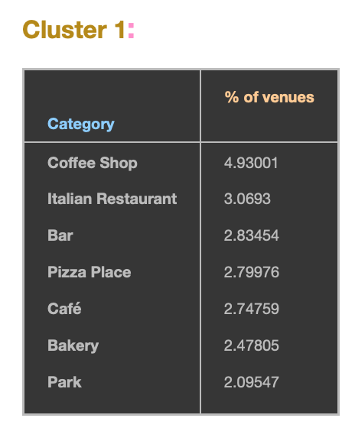

Observations: Coffee Shop is the most popular category with 9.9% followed by Italian restaurant. Bar, Pizza place, Café. Bakery and park are all more or less between 2 and 3%.

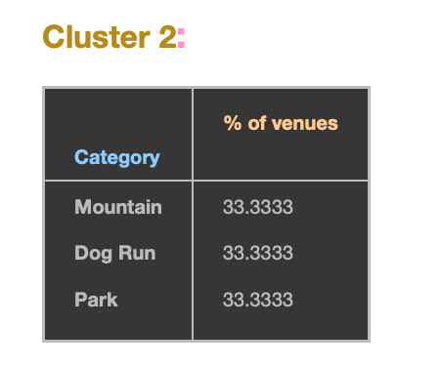

Observations : Mountain, Dog run and park all share 33%.

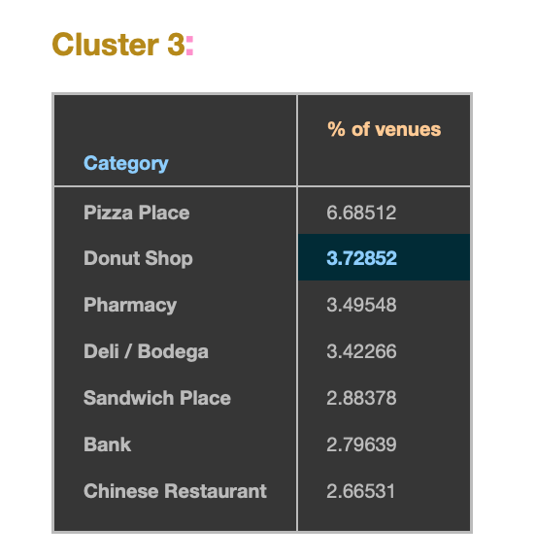

Observations : Pizza place is the most popular with 6.6% followed by Donut Shop, Pharmacy,Deli with approx. 3.5%,

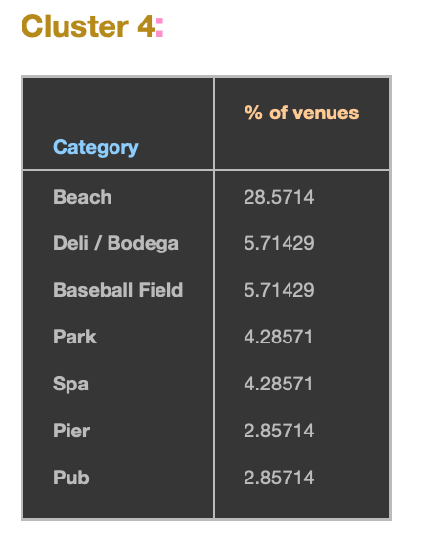

Observations: Beach is the most popular category of venue with 28% followed by Deli and Baseball field. It also includes SPA with 4% and is probably a good service to run in Cluster 4.

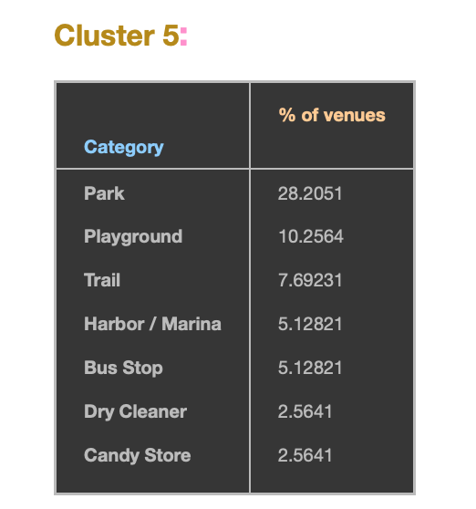

Observations : Park is 28% followed by Playground and Trail which do not make business sense. The Services Dry cleaner and Candy store are 2.5% respectively and might be a good service to give in Cluster5.

The differences between the clusters can be seen from the figure; each cluster distinguishably has different distribution of common venue categories than other clusters. Some of the observations that can be made from the tables of Figure 31 are:

* While Park constitute 2% of venues in the neighborhoods of the first cluster, they constitute 33% of the venues in the second cluster, 4% of the venues in the fourth cluster, and 28% of the venues in the fifth cluster.
* Pizza places appear in the most common categories of the first, and third clusters only.
* Italian restaurants appear in the most common categories of the First cluster only.
* Chinese restaurant appear in the most common categories of the third cluster only
* Beach is a very popular category in cluster four.

Figure 31 shows the number of NYC neighborhoods and the number of Toronto neighborhoods in each cluster of the five resulting clusters.

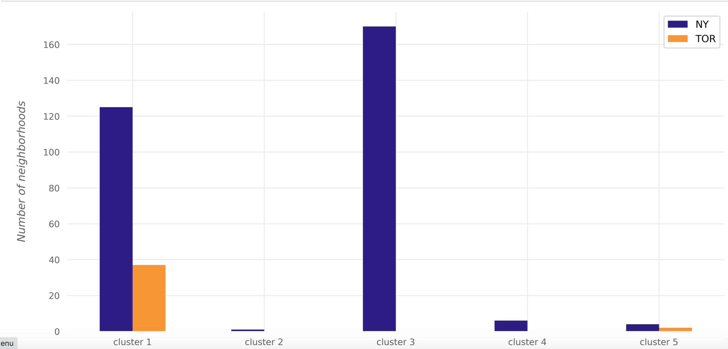

Figure 55: The number of NYC and Toronto neighborhoods in each cluster

# 6. Conclusions

To conclude, the neighborhoods of New York City and Toronto were clustered based on the categories of the venues in these neighborhoods. The results showed that there are venue categories that are common in some of the clusters than the others; the most common venue categories differ from one cluster to the other. Some venues are more popular than other venues in the same cluster.

With this, we can conclude that K-Means clustering algorithm can be effectively applied to find similarity or dissimilarity of neighborhoods.